GUIDELINES FOR CUSTOM ACTIVITIES

# Common Namespace Convention

Roboyo . Gmail . Activities . ActivityName

Second-Highest Level

Highest Level

**Note1**: Activities that doesn’t belong to an application should have as **second-highest level** “**Tools**”  
  
**Note2**: The activity name should be meaningful. The InArguments as well as OutArguments also. Furthermore, a description for the activities and the arguments should be added as well. Here is an example:

Custom Activity Name

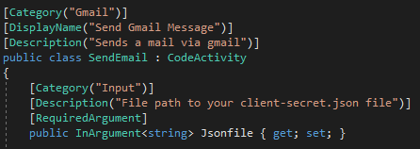

# Building Nuget Package

* We should always use the Roboyo icon.
* The title should follow this pattern: **Roboyo.<Application Name>.Activities**.
* The auhors and owners should always be **Roboyo**
* A description of the package should also be added
* Insert a link to the terms and Conditions/License type should be associated
* Version: starts from 0.0. Every change made before publishing the component increases the “decimal” index (0.1 for example). When we publish a version of the component, we consider it as a major update (1.0 for example)
* The dependencies of the package should also be mentioned. That means all DLLs the package depends on should be added to the package.

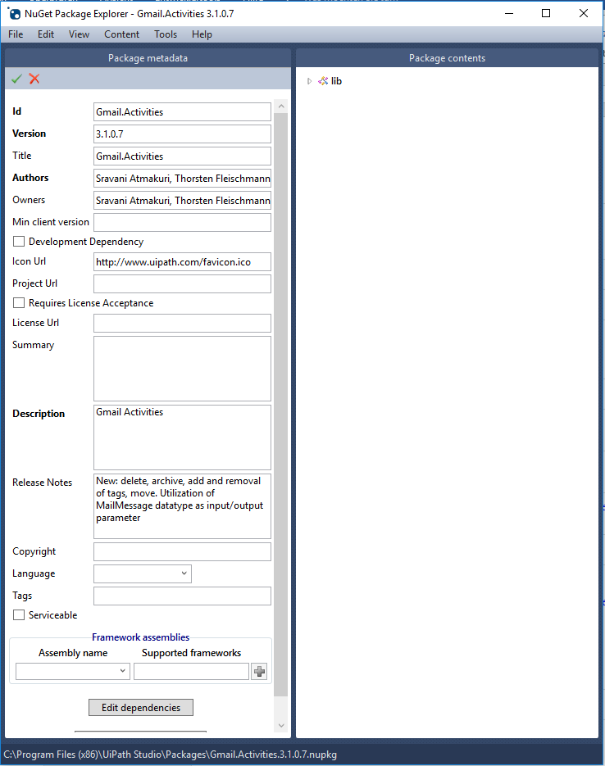

# TFS structure

There is a project called “Marketplace” in TFS under: **Roboyo/ Custom Code/ RoboyoLib/ Marketplace**, where the activities can be added. The name of the folder should start with **Roboyo.** Furthermore, should be appended, either the name of the application you built custom activities for, or the name **“Tools”** as shown in the picture. The following picture shows the requirements of the structure for each project.

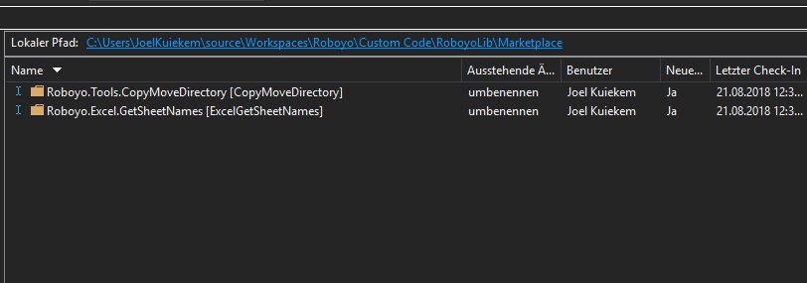

The sub-folders should have the following structure:

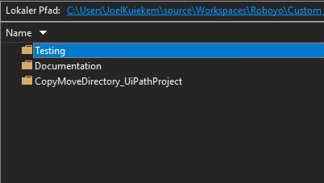

“**UiPathProject**” should be appended to the activity name to create one folder. The **documentation** folder is mandatory, but the **Testing** folder is not.

# Installation guide

A guide regarding the installation of the package should be provided

# User Guide

All details of usage of the component should be provided.